CURRICULUM VITAE

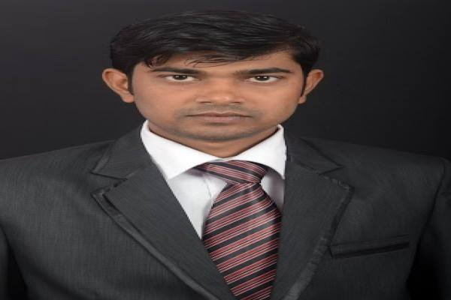

# 

# 

Name - Tushar Mondal

**Address :** Vill + Post Office –Kulberia, Police Station - K.L.C.

Dist-south 24 Pargana, Pin no -743502

**Mobile No** : +919874809785

**E-mail**  : [tusharmondal033@gmail.com](mailto:tusharmondal033@gmail.com)

**Academic Qualifications:**

|  |  |  |  |  |
| --- | --- | --- | --- | --- |
| **Degree/Certificate** | Institute | Board/University | **Year** | **%** |
| M.A | Calcutta University | Calcutta University | 2010 | 40.65 |
| B.A | Bhangar Maha Vidyalaya | Calcutta University | 2008 | 53.5 |
| Higher Secondary(XII) | Sonarpukur Vidyapith | W.B.C.H.S.E | 2005 | 52 |
| Madhyamik(X) | Sonarpukur Vidyapith | W.B.B.S.E | 2003 | 52.75 |

**Work experience:**

|  |  |  |
| --- | --- | --- |
| **Name of Organization** | **Designation** | **Duration(in months)** |
| Orion Edutech | Marketing Executive | 7 months |
| Citysmart Aviation Pvt.Ltd | Business Development Executive |  |

Roles and Responsibilities in **Orion Edutech**:

* Collect contact number from customer and Maintain contact with Key Clients
* To manage the production of marketing materials, including leaflets, posters and flyers
* Work with Marketing manager and attending marketing campaign to generate new business and raise awareness of company products

Roles and Responsibilities in **Citysmart Aviation Pvt.Ltd**

* Generate business in order to achieve target level
* Dealing with candidates
* Maintain an accurate and current database
* Conduct telemarketing to schedule interview and follow up quotations
* Maintain established minimum standard of performance.
* Daily Ad posting in different job Portals
* Send Daily Activity report to the Center Head

**Computer Proficiency:**

* **Applications:** MS Office
* **Databases:**  Access

**Achievement:**

* Highest business holder in the month of May, 2014 and received “*Performer of the Month*” Certificate from Managing Director at Citysmart Aviation Pvt. Ltd.

**Hobbies and Special Interests:**

* Playing cricket
* Listening soft music

**Personal Details:**

**Date of Birth :**  03/13/1987

**Gender** **:** Male

**Languages Known :** Bengali, Hindi & English,